

**POINT OF SALES MANAGEMENT SYSTEM FOR ASIAN DISTRIBUTORS**

Proposal, Technical Project

By

Group - BLITZ Code

Client Mr. M.Z.M. Shahlan

Prepared by:

M.Z.A. Rahman, M.N. Salmanul Faris, H.K. Najumudeen., F.A. Ozeer, H.N. Ahamed

Version 1.0

Date:01.08.2021

This proposal is submitted to the Information Technology department in partial fulfillment for the PPA module in the Diploma in Information Technology program.

# DECLARATION

We hereby declare that the project work entitled “POINT OF SALES MANAGEMENT SYSTEM FOR ASIAN DISTRIBUTORS”, submitted to the SLIIT Academy (Pvt.) Ltd. a subsidiary of Sri Lanka Institute of Information Technology is a record of an original work done by us, under the guidance of our Supervisor “Mr. Roshan Jayawardana”. This project work is submitted in the partial fulfillment of the requirement for the award of the Diploma in Information Technology. The Results embodied in this report have not been submitted to any other University or Institution for the award of any degree or diploma. Information derived from the published or unpublished work of others has been acknowledged in the text and a list of references is given.

**Project ID:**

**Group Members:**

|  |  |  |
| --- | --- | --- |
| **Student ID** | **Student Name** | **Signature** |
| IT20766450 | M.Z.A. Rahman |  |
| IT20761264 | M.N. Salmanul Faris |  |
| IT20764548 | H.K. Najumudeen |  |
| IT20044640 | F.A. Ozeer |  |
| IT20764616 | H.N. Ahamed |  |

**Date of Submission:** ……01.08.2021………………….

**Name of Supervisor:** Mr. Roshan Jayawardana

…………………………….…

**Signature of the Supervisor**

Table of Contents

DECLARATION i

LIST OF TABLES iv

LIST OF FIGURES iv

1 INTRODUCTION 1

1.1 BACKGROUND OF THE CLIENT/ PROJECT 1

1.2 PROBLEM STATEMENT 1

1.3 NEEDS STATEMENT 1

1.4 SOLUTION AND OBJECTIVES 2

2 PROPOSED TECHNICAL APPROACH 3

2.1 DEVELOPMENT METHODOLOGY 3

2.2 REQUIREMENT GATHERING 3

2.3 ARCHCITECTURE DIAGRAM 3

2.3.1 AS IS SYSTEM 4

2.3.2 TO BE SYSTEM 5

2.4 FUNCTIONAL REQUIREMENTS. 5

2.5 NON-FUNCTIONAL REQUIREMENTS 5

2.6 IMPLEMENTATION AND DEVELOPMENT REQUIREMENTS. 6

2.7 RUNNING ENVIRONMENT REQUIREMENTS 6

2.8 QUALITY ASSURANCE PLAN 6

3 EXPECTED PROJECT RESULTS 7

3.1 DELIVERABLES 7

3.2 MEASURES OF SUCCESS 7

4 BUDGET 8

5 ROLES AND RESPONSIBILITIES 9

6 SCHEDULE 10

7 REFERENCES 11

8 APPENDICES 12

# LIST OF TABLES

Table 4.1: Employee budget 8

Table 4.2: Total budget 8

Table 5.1: Roles and responsibilities of the project. 9

# LIST OF FIGURES

Figure 2.1: Waterfall development methodology 3

Figure 2.2: AS IS System 4

Figure 2.3: TO - BE System 5

Figure 6.1: Schedule 10

Figure 6.2: Gantt chart 10

# INTRODUCTION

The Asian Distributors is managed by M.Z.M. Shahlan. They are currently involved in sales of mobile and accessories etc. Apart from main shop. Currently The Asian Distributors use a manual system that monitors the salary and stock that is been recorded in a book that needs to be maintain frequently. The Asian Distributors doesn’t have a proper method to calculate balance and income of goods. Since the documentation is managed manually it error prone and waste time therefore the system is properly needed to organize the data because it is a risk to keep the data without any security measures as it can be stolen/destroy. Mainly this project is created to the system that calculates profits, finding the routes located and stock inventory as a record.

## BACKGROUND OF THE CLIENT/ PROJECT

The Asian Distributors are in a small chain Managed by M.Z.M. Shahlan. They are currently involved in sales of mobile and accessories etc. This will provide an insight to the current option of the client requirements analysis, design and implementation of propose system. It the testing method and test case of the system, lastly future enhancements that could be done as a system.

## PROBLEM STATEMENT

As a current The Asian Distributors is used manually on record books that need to be managed therefore, we use a method error prone free and waste time therefore we come upon a system which would manage all the records in to one system frequently.

## NEEDS STATEMENT

With the proposed system we get information on inventories sales as a record. So that the client can generate, and analyst detailed reports on current and past transaction, payments, sales, routes located and etc. Through this system client can perform and take the necessary steps in order to prove the business and client frequently.

## SOLUTION AND OBJECTIVES

Are project here by a solution to maintain the business and keep it upgraded in a successful manner. Therefore, the main objective of our projects is to develop a system for stock handling, payroll, route located and balance and income calculation for our company.

# PROPOSED TECHNICAL APPROACH

The Asian Distributors are controlling to manage and maintain stock in our company and get generated with views and maintain profits and balance to the report. We also control a central database to connect and store data of the company. We secure access with role only by administrator. This system maintains payrolls as a online system.

## DEVELOPMENT METHODOLOGY

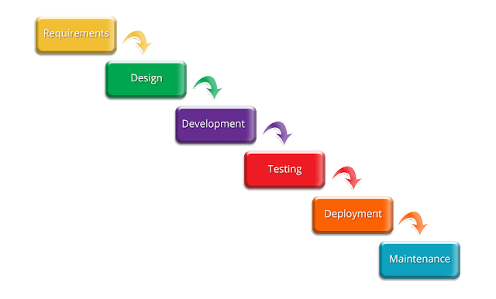

Figure 2.1: Waterfall development methodology

## REQUIREMENT GATHERING

In waterfall development system the client requirements to gatherer at the starting of the project to develop a team which won’t have to intervened with the client until the end of the project.

We also use the other method analysis, design, implementation, testing, deployment, and maintenance. We include all of these method into the waterfall system.

## ARCHCITECTURE DIAGRAM

In our The Asian Distributors system we maintain three main functions as,

**Repair**- receive date, received shop, phone model, issues, receive only the phone or as a whole unit and return date.

**Stock**- brand, model, quantity, cost, selling price

**Route**- this distributes to many locations that have been sold out to the particular shop and that shop displays all the details as balance-income, last order-amount and order history.

### AS IS SYSTEM

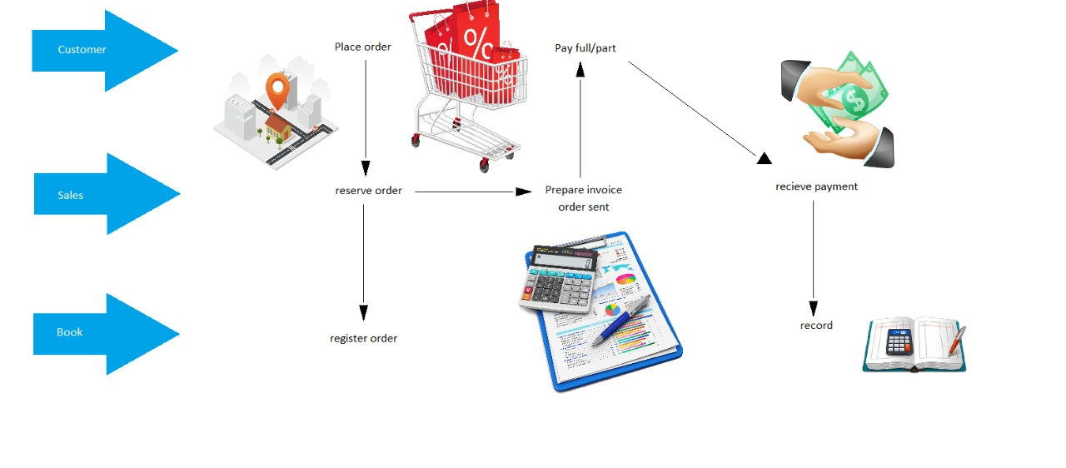

Figure 2.2: AS IS System

Currently business records are stored in a book. Through the book client can’t properly calculate the profit, balance to be received from customers.

### TO BE SYSTEM

The below diagram gives a clue about the system we are going to create.

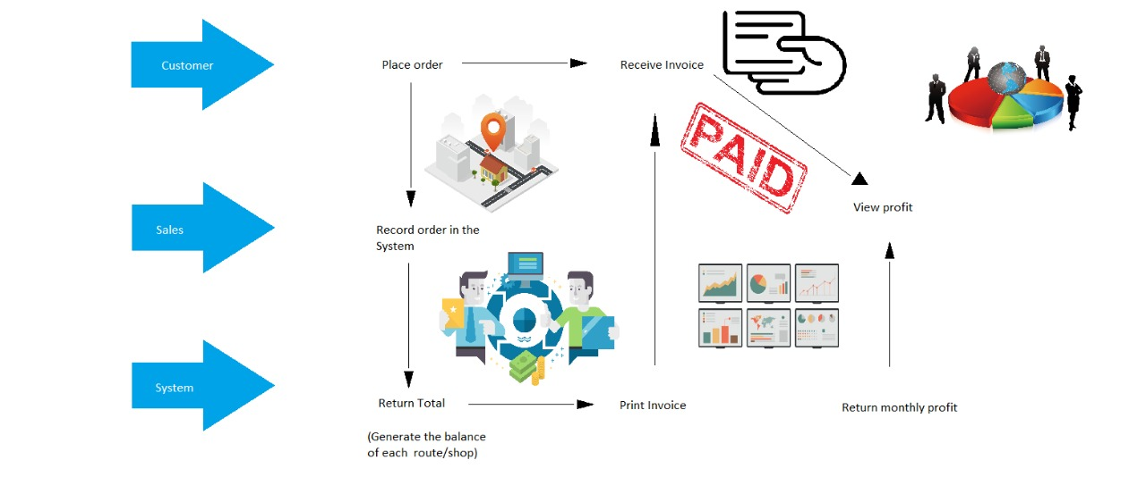

Figure 2.3: TO - BE System

## 

## **FUNCTIONAL REQUIREMENTS**.

* Only manager can use the system by login into the system. So, it’s secured.
* Admin can add, update, and delete stokes.
* When a repair is received by the user, he can store those details in the system. Details like repair received and hand overed date, shop received from and issue.
* User can analyze balance that has to come from the routes/customers, order history.

## NON-FUNCTIONAL REQUIREMENTS

This defines a non-functional criteria was necessary to avoid creating conflicts by developing the software. So Non-functional requirements will be accessible to the system available 24 hours and 7 days a week. System can be installed in android mobile phones or tablets. Also, the system is user friendly and security base.

## IMPLEMENTATION AND DEVELOPMENT REQUIREMENTS.

* PC Windows / Mac.
* Android studio IDE.
* Java installed in PC.
* Android device to run check (optional) – android studio inbuild android virtual machine can be use.

## RUNNING ENVIRONMENT REQUIREMENTS

This interface is design for the user to use easily and understandable.

System requirements:

* Android mobile or tablet.
* Android system version 4.+.
* Ram 1GB or more.

## QUALITY ASSURANCE PLAN

The quality assurance plan was designed with the purpose of ensuring that the project meets the quality that the client want.

The system will go through a testing phase to overcome problematic processes and improve the quality of the software, where the team will provide the client with a fully functional prototype. Finally, the system will undergo the multiple cycles of the testing methods and During this testing phase the team will make improvements whenever needed to assure that system’s quality lives up to the client’s standards and the team’s standards as well.

# **EXPECTED PROJECT RESULTS**

Client can manage his business easily and reliably. By looking at the profit that he can generate through the system, he can feel relaxed.

## DELIVERABLES

* There’s an interface to view manage and generate report.
* There should be a password protected access.
* There’s an interface being recorded on transactions.
* Must have an interface to manage cash receipts for goods.
* Sales and inventory should be recorded.
* There are routes to manage/access branches.
* There should be a user-friendly interface that is easily accessible.

## **MEASURES OF SUCCESS**

In this system we mainly arise the option on how to manage the business with a handheld software system which would be easy and understandable for the client to store record manually without any corruption and maintain the system without any failure and successfully.

# BUDGET

Estimated budget for the project.

Table 4.1: Employee budget

|  |  |  |  |
| --- | --- | --- | --- |
| **Role** | **Hourly wage (LKR)** | **Estimated No. of hours** | **Total (LKR)** |
| Project manager and tech lead | 1500 | 40 | 60,000 |
| Frontend developer | 480 | 55 | 26,400 |
| UX/UI designer | 450 | 50 | 22,500 |
| Database administrator | 530 | 40 | 21,200 |
| QA engineer | 460 | 30 | 13,800 |
| **Total Employee Cost** | | | 143,900 |

Table 4.2: Total budget

|  |  |
| --- | --- |
| **Elements** | **Total (LKR)** |
| Employee cost | 143,900 |
| Hardware cost | 15,000 |
| Documentation cost | 2,000 |
| Travel cost | 1,500 |
| Virtual meeting | 1,500 |
| **Total Estimated Cost** | **163,900** |

# ROLES AND RESPONSIBILITIES

Table 5.1: Roles and responsibilities of the project.

|  |  |  |
| --- | --- | --- |
| **Role** | **Responsibility** | **Participant(s)** |
| Project Sponsor | coordinating project work | M.Z.A. Rahman |
| Project Leader | Managing the project work | M.Z.A. Rahman |
| Database administrator | Managing the Database | H.K. Najumudeen |
| Design | User interface development | H.N. Ahamed |
| Implementation | Developing the algorithm for calculation and other functions | M.N. Salmanul Faris |
| Testing | Framing the Documentation | F.A. Ozeer |

# SCHEDULE

Our main tasks are requirement gathering, requirement analysis, design, develop and test.

Figure 6.1: Schedule

Figure 6.2: Gantt chart

# REFERENCES

|  |  |
| --- | --- |
| [1] | M. Lotz, "Waterfall vs. Agile," Segue Technologies Inc, 05 July 2018. [Online]. Available: https://www.seguetech.com/waterfall-vs-agile-methodology/. [Accessed 17 July 2019]. |

# APPENDICES